**Project Specifications**

**Dice and Rules Toolkit**

An application developed to provide concise definitions and examples for the standard terms of Dungeons & Dragons 5th edition

**Submitted to**

Suncoast Technical College

.Net Applications Development and Programming

Instructor: Mr James Hornberger

**Submitted by**

Ben Caruthers

**Introductions**

When in the course of enjoying a game of Dungeons and Dragons, there are often scenarios in which people don’t know the rules.The game is fairly slow to begin with and is brought to a halt when rules and specific situations warrant further investigation into the rule book. Players and Dm’s alike don’t want to have a stack of papers or books keeping track of their game in addition to spell lists and myriad other character data necessary. This diaspora of rulings and notes could be brought together in a simple desktop application.

Contained in this application are the following resources:

* A dice roll simulation for 20, 12, 10, 8, 6 and 4 sided dice
* An initiative tracker for both players and adversaries
* A quick reference tab describing player actions, player skills, keywords, situational rulings and status effects

**Outputs**

* resultLabel.Text displays a result of dice rolls
* initiativeListBox displays data from a struct called Charturn holding a name followed by a given number
* infoTextBox displays game information in a string

**Inputs**

* Dice number buttons allow a different range of random outcomes and correspond to a variable called maxRange
* A numericUpDown tracker accepts different whole numbers between 1-10
* userBonusTextBox accepts text and tries parsing it to a number called userBonus
* initiativeTextBox accepts a name and number
* The rules description tabs activate based on click events and selection changes

**Constants**

* There are no constant variables in use in this program at this time.

**Formulas**

* There are no significant or complex mathematical formulas at this time.

**Pseudocode**

Dice Roller

1. A user clicks a button stating what size dice to roll.
2. Generates a random number between 1 and the maxRange
3. Add bonus to roll if any in userBonusTextBox
4. Show the number rolled to the user
   1. If user wants to roll more than one die at once, roll the specified dice the selected number of times while adding the result each time

Turn Order Tracker

1. Takes line of input from user in initiativeTextBox called line
2. Splits line and assigns data to new CharTurn object
3. Adds input to a CharTurn list and returns a copy of the list sorted by initiative
4. Clear listbox of previous data
5. Show sorted list in initiativeListBox
6. Clear text and refocus on initiativeTextBox

Rules/Skills Info Tabs

1. These are all based on click events. If a user selects an option, the relevant text is displayed below in a large text box.

**Conclusion and Future Development/Enhancements**

While working on this project, my time was largely split between reading through game rules and formatting the text. The effort to condense the pages of rules and definitions into their most important details took most of my time as the functions and code are fairly simple. I tried a few controls I’ve not used previously which left certain things looking a little different as a result. As the program is intended to be a simple quick reference I spent little time on aesthetics. A line between point A (having a rules question) and point B (resuming the game) I wanted the form itself to draw as little attention as possible.

As it is right now the program performs all the tasks needed and should help reduce downtime while playing/running a game. The potential for additional features includes substantive and presentational matters. There are a few small visual incongruities like the four sections not lining up the way I wanted. Group boxes consider their “top” an invisible line along the top of their title text. This makes lining them up with other features to the side needlessly difficult. This is one example I decided not to fix. On the content side I could also add a searchable spell listing with a database holding all 400+ spells now in the game. There could also be added animations/sounds or images in the dice roller that show a picture of the result rather than a label.

In the end it ended up being a little less “coding” and a lot more “rules analysis” than I might have expected at the outset. I did end up posting it on github.com, so that was something new I intend to grow more familiar with in the future. At the same time it does exactly what I needed it to do.

**References**

* D&D Basic Rules, Version 1.0, Released November 2018

Available for download at dungeonsanddragons.com

* D&D Micro Instructions – Condensed rules for your players to reference. Created and shared by reddit user u/otown_in_the_hotown.

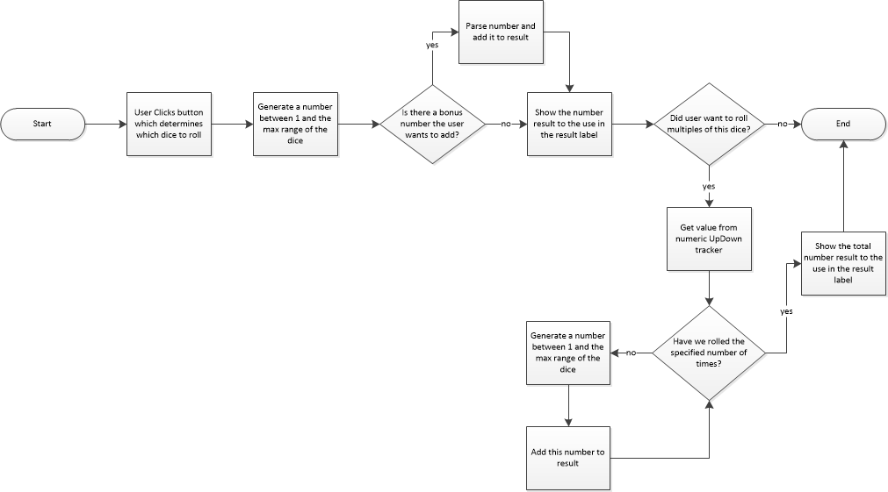

ScreenShots

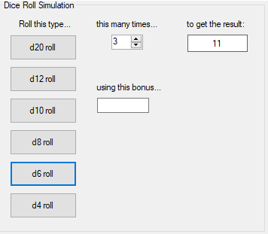 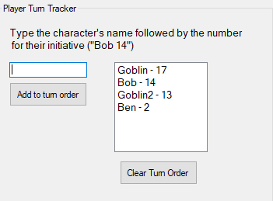

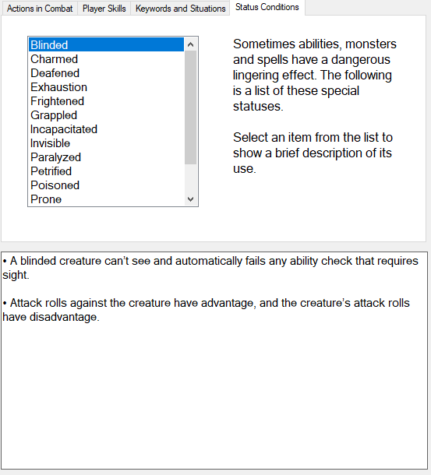

Screen Shots cont...

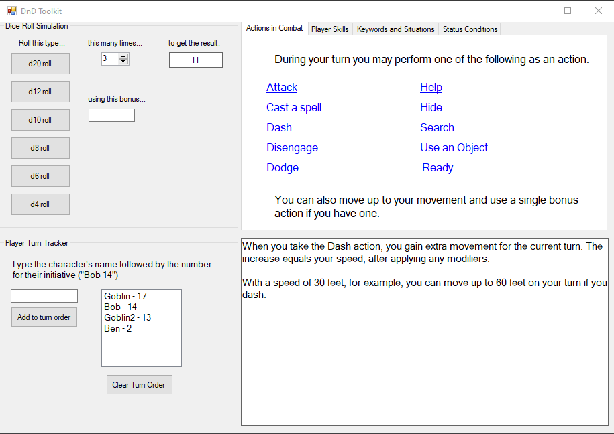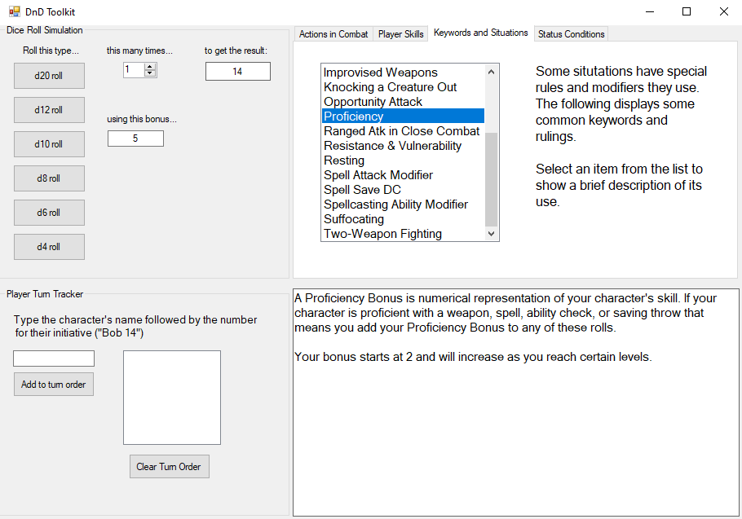

Sample Code 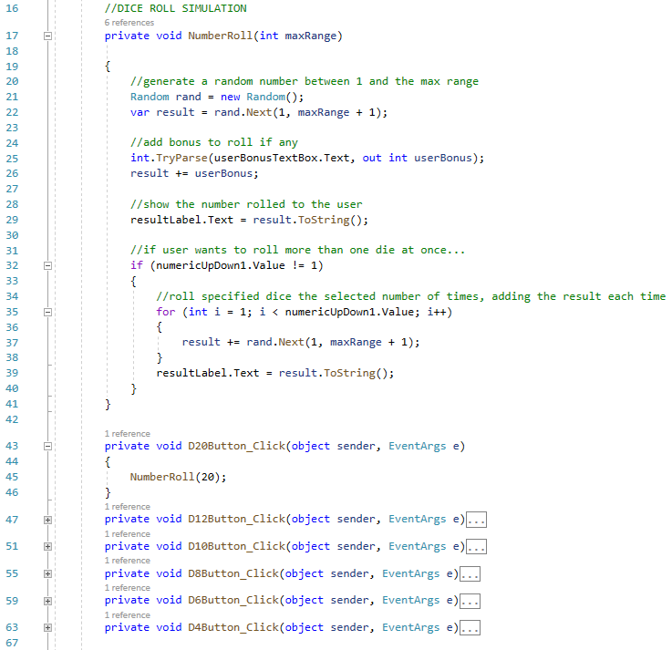

**Developer Profile**

Ben Caruthers is beginning down the path of a C# developer. He has been writing code and D&D adventures for about 1 ½ years now and enjoying them both. He enjoys Jazz, games, and his dog Winston. He can be reached at [bencaruthers@sbcglobal.net](mailto:bencaruthers@sbcglobal.net) and this program can be accessed for free as an exe file at <https://github.com/Bcaruthers91/DnD-Toolkit>